
TECHNICAL DESIGN DOCUMENT
Hotel Management System

Team Name: Nirmaan
Team Members:
Akash Deep
Aman Raj (46001967)
Diksha Gupta (46003707)
Rohit Kumar

FUNCTIONAL REQUIREMENT ANALYSIS:

As an Admin:
- Login / Logout:
System administrator should be able to login with valid credentials. And validation should be provided for Admin ID and Password.
- View / Edit profile:
Admin should be able to view his personal profile and update it whenever required.
- Search / update / delete hotels:
For a system admin functionality of searching hotels using city name, hotel name should be provided. After searching the desired hotel, admin should be able to see a list of hotels (according to given city name).
There should be options to delete hotel and update various hotel details I.e., total rooms, different amenities etc.
- Add hotels:
If a new hotel has come into the picture, then there should be an option to add new hotel into the system. While adding new hotel, all the details should be filled in proper manner I.e., Hotel name, city, Hotel desk no., amenities provided, No. Of rooms and pictures of rooms etc.

As a customer:
- Register new user:
A new user should be able to register himself in the system by providing details like Name, mobile no., email address, password and a security question.
All details should be validated accordingly.
- Login/Logout:
A registered customer can login using valid credentials.
user ID should be validated first and if customer is not a registered user then it should show an appropriate message. Then password should be validated.
- Search and filter hotels:
Functionality of searching hotels based on hotel name, city name, check-in, check-out date and number of guests should be there. According to these given details the list of available hotels should be visible to the customer.
Few filters like, price range, rating etc. Should be provided to enhance the search results.
- Book Hotel:
Once the desired hotel is selected customer should be able to book that hotel room. For that purpose, customer is asked about various details (name of guests, no. of guests, age, check-in, check-out date etc.).
After fulfillment of these details, customer should be able to go to payment option where he/she can select any payment mode from given options.
- Profile management:
A customer can review his/her profile and update the profile.
- Review/cancel reservations:
Functionality for viewing all the reservation for that customer should be there. Also he/she should be able to cancel any upcoming reservation.
Feedback option should be given so that customer can give their opinion about their stay in the hotel. This option should only be visible in those hotels where customer has stayed in past not for upcoming reservations.

MICROSERVICES AND THEIR INTERACTION:

Authentication management system:
It has the following tasks:
- Allows an admin to login.
- Allows a new customer to register.
- Allows an existing customer to login.
- Based on the user role (admin/customer), allows interaction with appropriate micro-services:
- Micro-services accessible to Admin – Hotel Exploration Micro-service, Hotel Catalogue Micro-service, User Profile Management Micro-service.
- Micro-services accessible to Customer – Hotel Exploration Micro-service, Hotel Booking Micro-service, User Profile Management Micro-service.
- Micro-services accessible to Unauthenticated User - Hotel Exploration Micro-service.

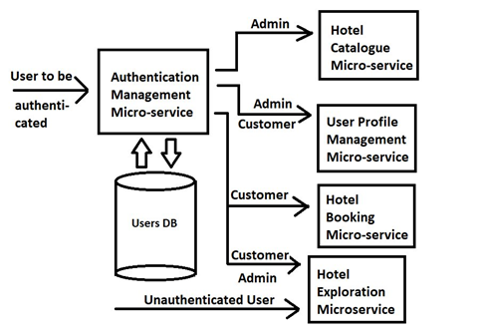

Hotel Catalogue Microservice:
It can solely be used by admin. It has the following tasks :
- 1. Allows an admin to add a hotel.
- 2. Allows an admin to delete a hotel.
- 3. Allows an admin to update details of an existing hotel e.g. name of hotel, location, pricing, number of rooms, amenities etc through the Hotels DB Management Micro-service. These details do not include number of rooms booked, number of booked rooms cancelled, rating of hotels etc.
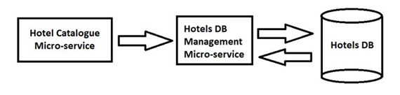

Hotel Exploration micro service:
It can be used by either admin, registered customer or unauthenticated user. It has the following tasks:
- Allows a user to enter name of hotel/location.
- Allows a registered customer or an unauthenticated user to enter check-in/check-out dates and number of guests.
- Allows a user to apply appropriate filters like – price range etc.
- Allows a user to browse hotels based on above parameters.
- Acts as gateway to edit/delete/book a hotel as per user role.

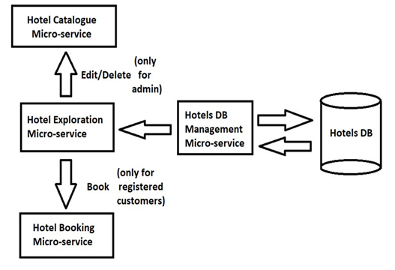

Hotel booking micro service:
It can be used by registered customers only. It has the following tasks:
- Allows to add details of guests like – name, age, gender, phone number etc.
- Displays the total fare of the stay.
- Provides different payment methods.
- Once a customer confirms and pays for the booking, this micro-service allocates rooms for the customer through Hotels DB Management Micro-service, adds a payment transaction record through Transaction Management Micro-service and adds an upcoming booking to the user-profile through User Profile Management Micro-service.

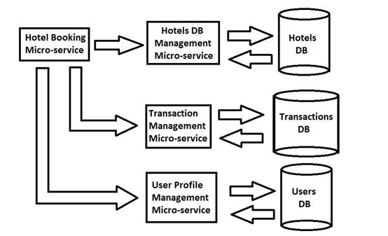

User profile management micro service:
It is used by admin and registered user. It has the following tasks:
1. Creates a customer's user profile during registration.
2. Allows a registered customer and admin to view/edit his/her profile.
3. Stores booking details of a reservation for a registered customer.
4. Allows a registered customer to view upcoming/past/cancelled bookings.
5. Allows a registered customer to update/cancel upcoming bookings.

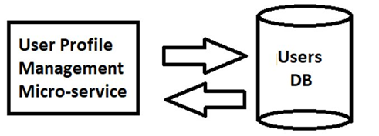

ACTIVITY DIAGRAM OF HOTEL MANAGEMENT SYSTEM:
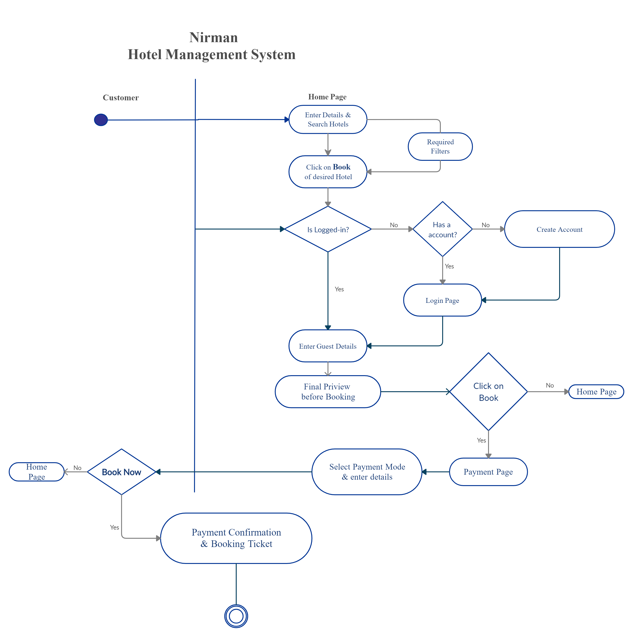

USE CASE DIAGRAM OF HOTEL MANAGEMNT SYSTEM:
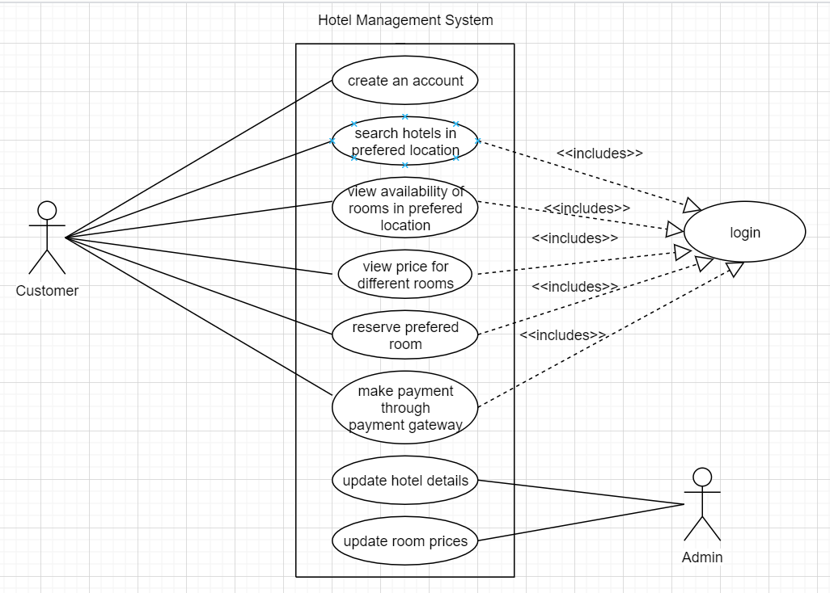

SEQUENCE DIAGRAMS OF HOTEL MANAGEMENT SYSTEM:

- Sequence Diagram of Registration system:
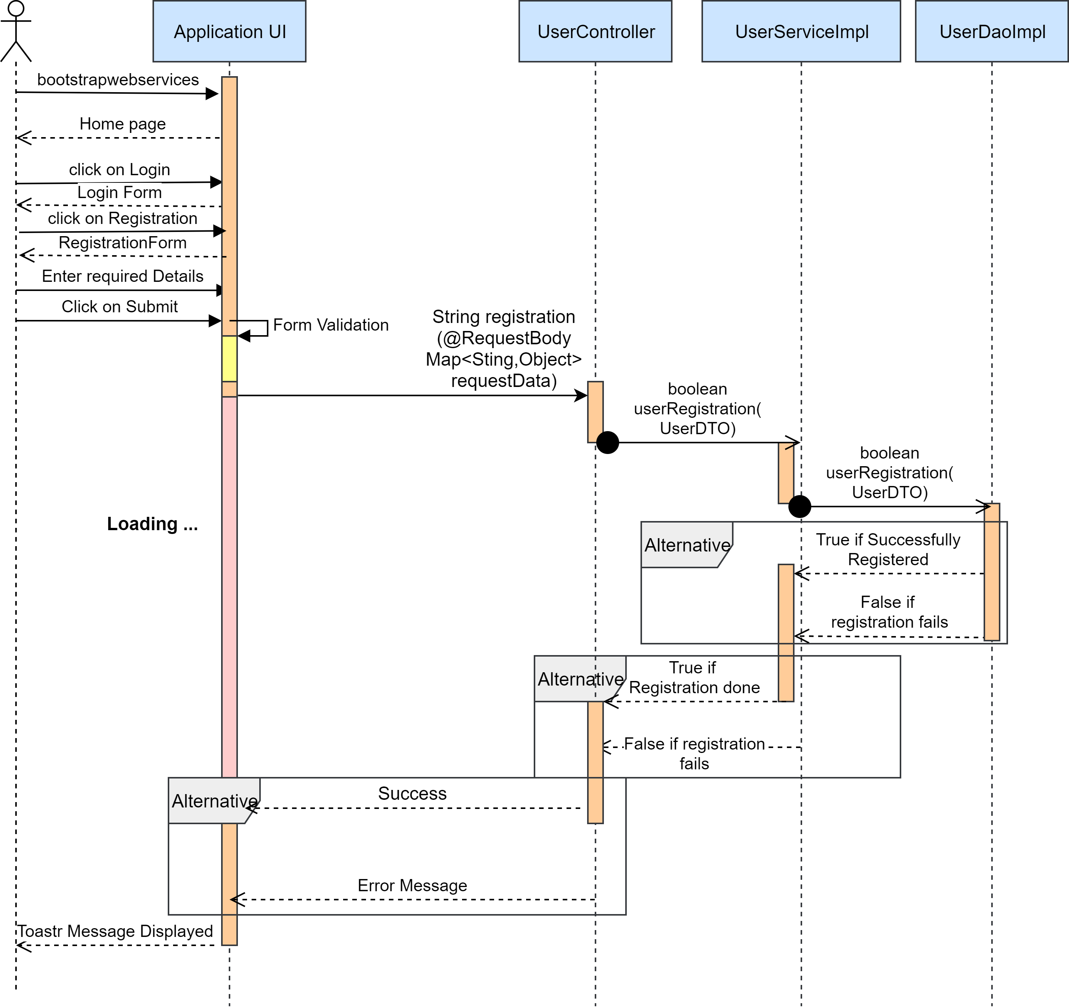

- Sequence Diagram of Login System:
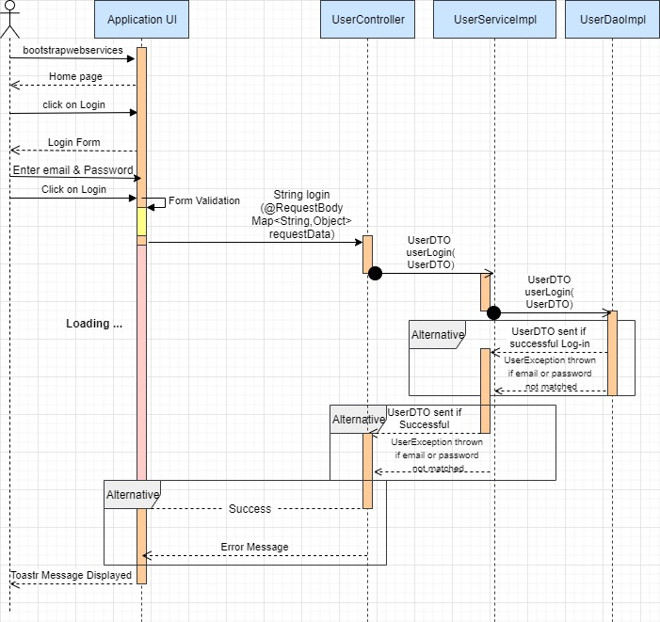

- Sequence Diagram of Logout:
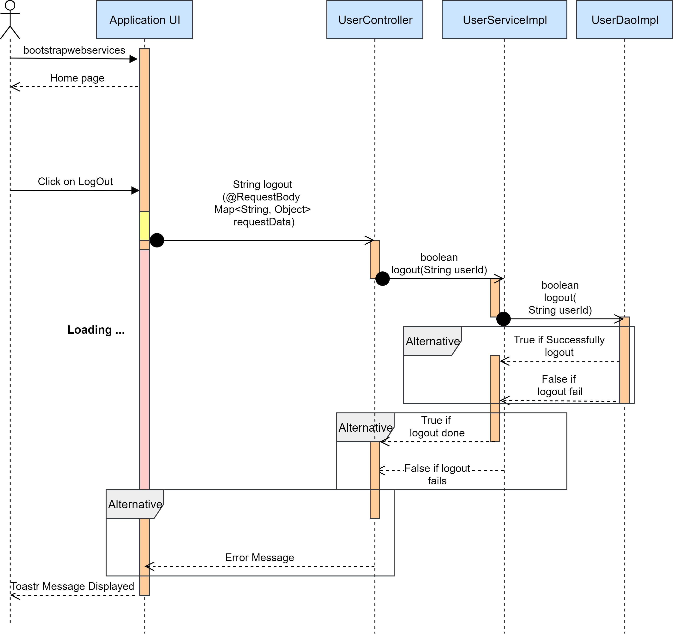

- Sequence Diagram of Hotel exploration system:
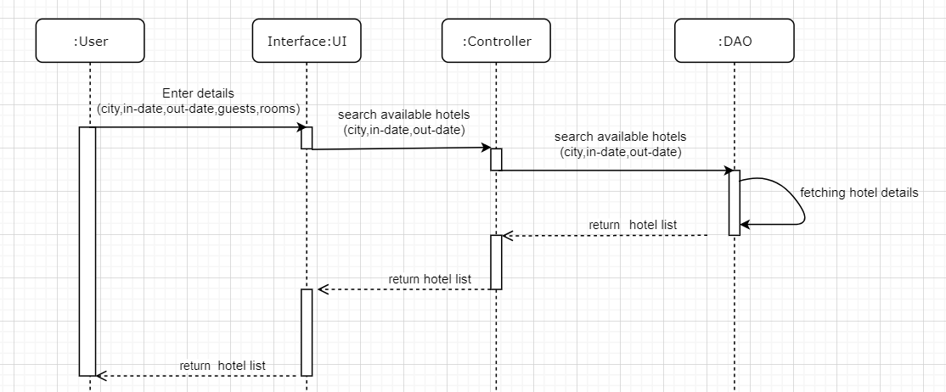

- Sequence Diagram of Booking system:

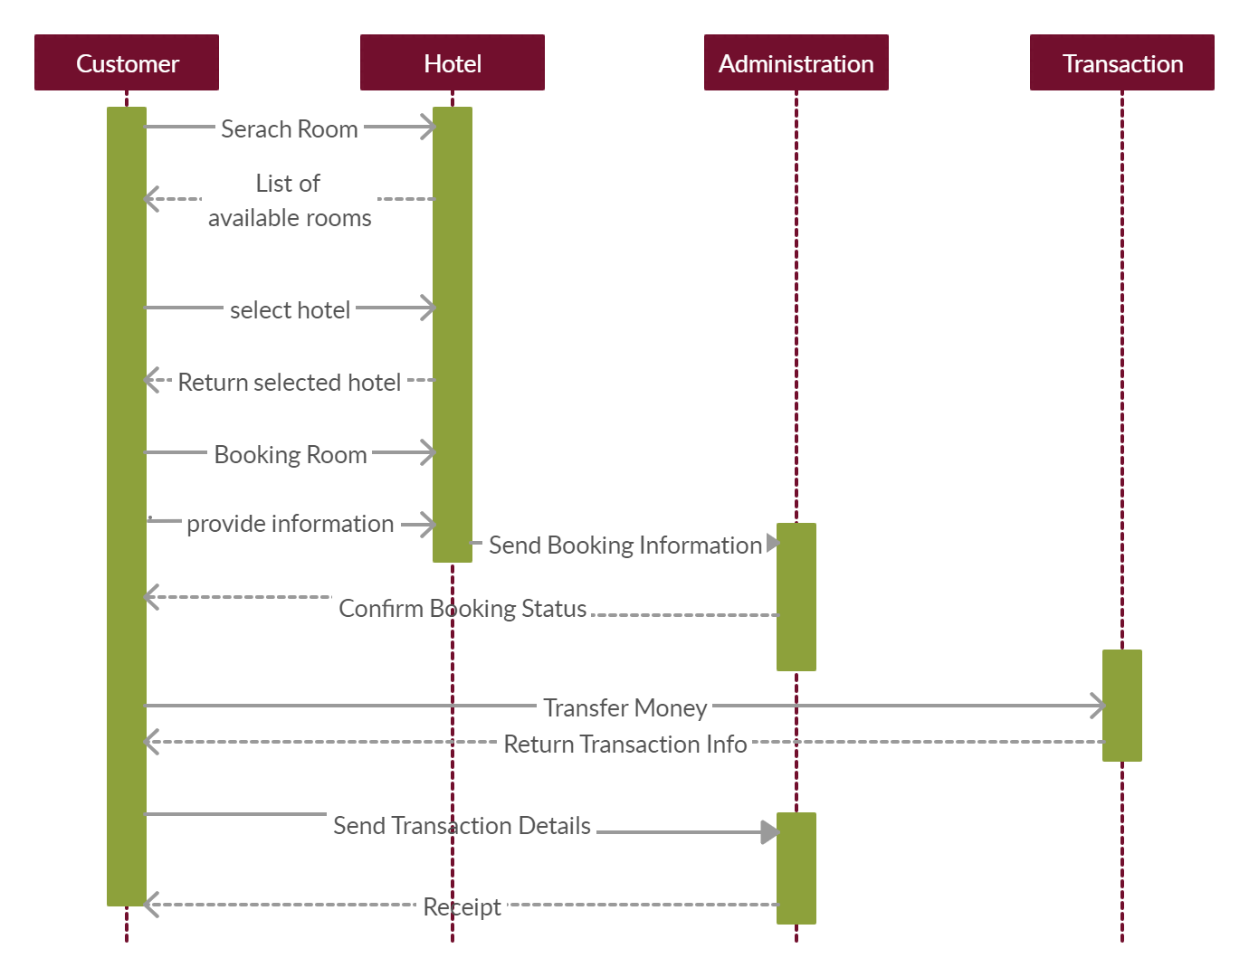

CLASS DIAGRAM OG HOTEL MANAGEMENGT SYSTEM:
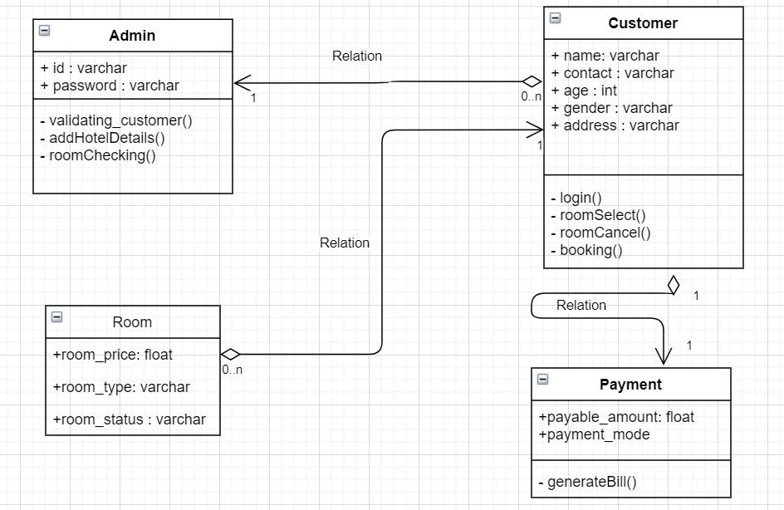
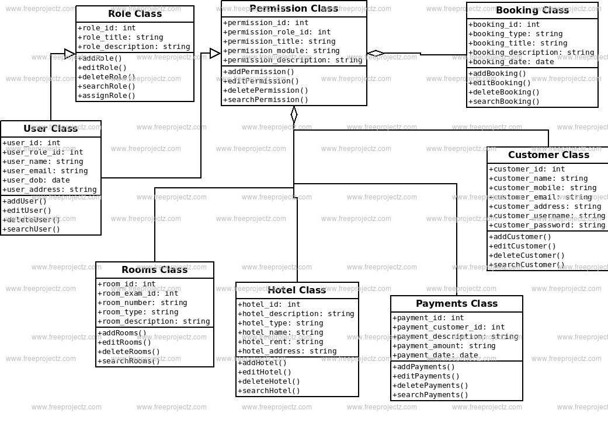

ER DIAGRAMS OF HOTEL MANAGEMENT SYSTEM:
ER DIAGRAM OF USER DATABASE:
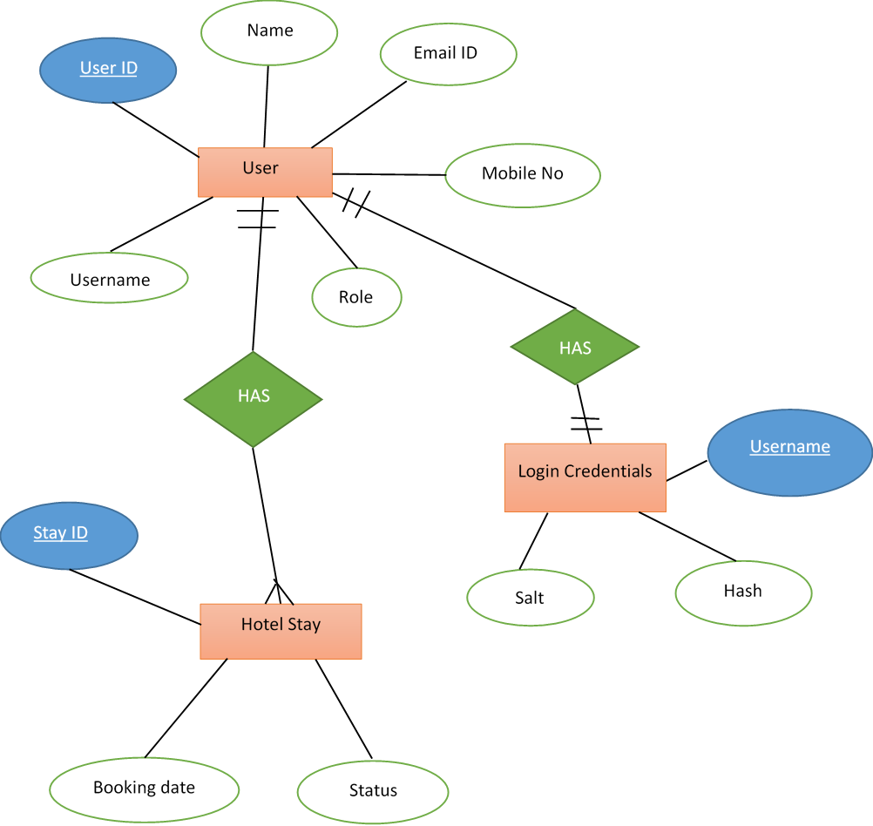

ER DIAGRAM OF HOTEL DATABASE:
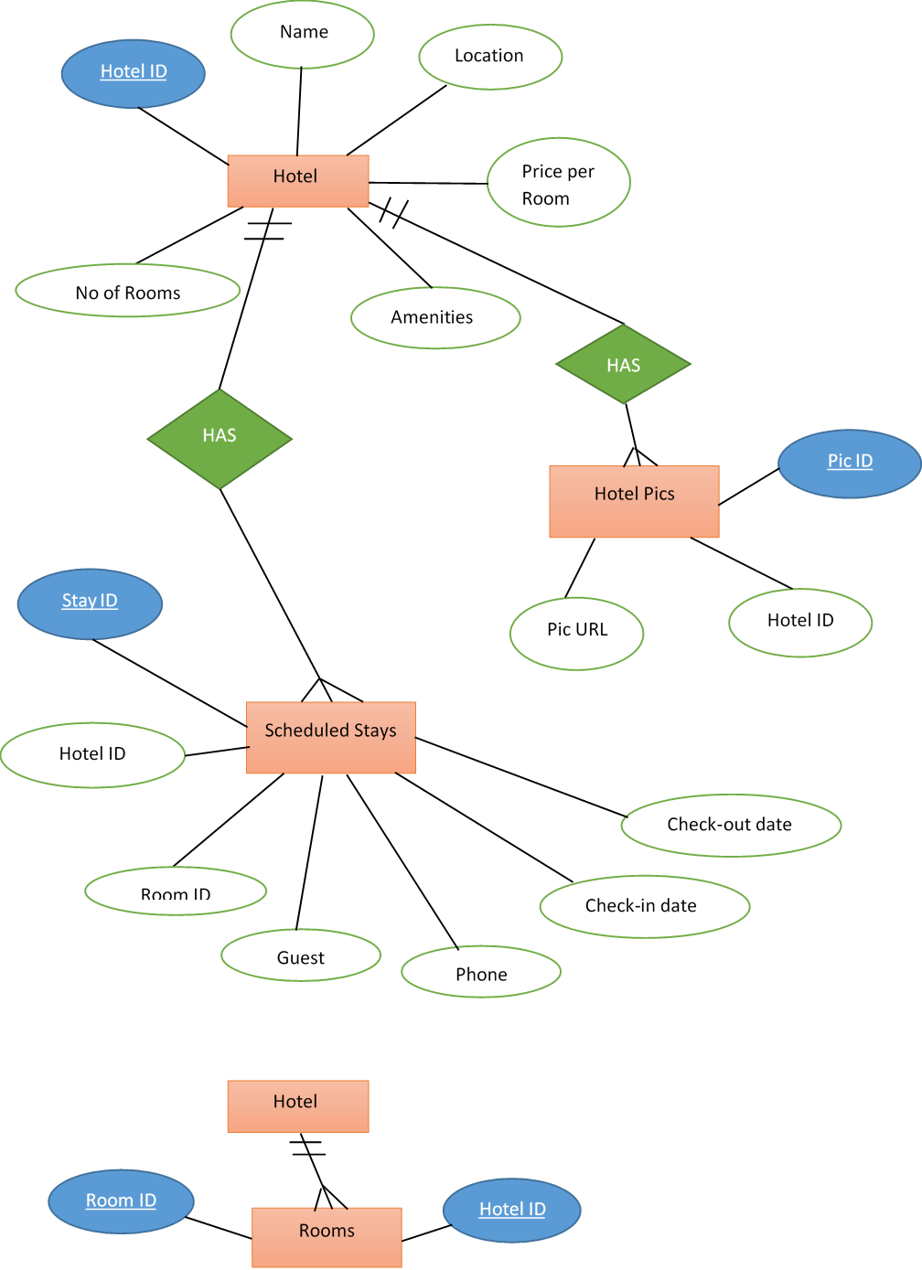

ER DIAGRAM OF TRANSACTION DATABASE:
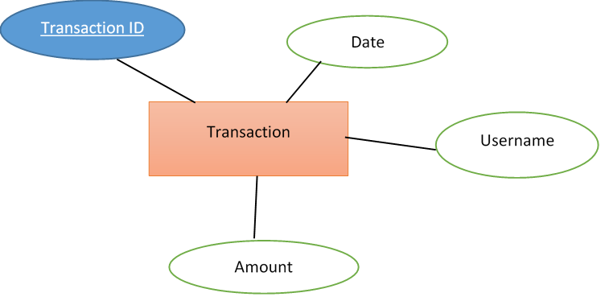

WIREFRAMES OF HOTEL MANAGEMENT SYSTEM:
Login page:
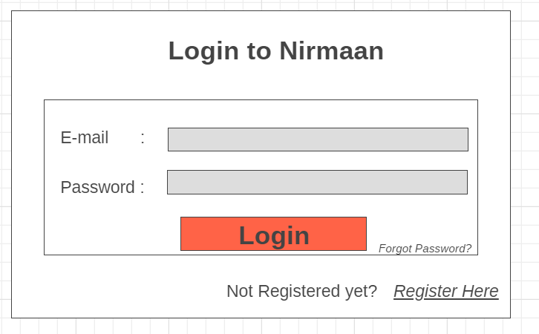

New user Registration page:
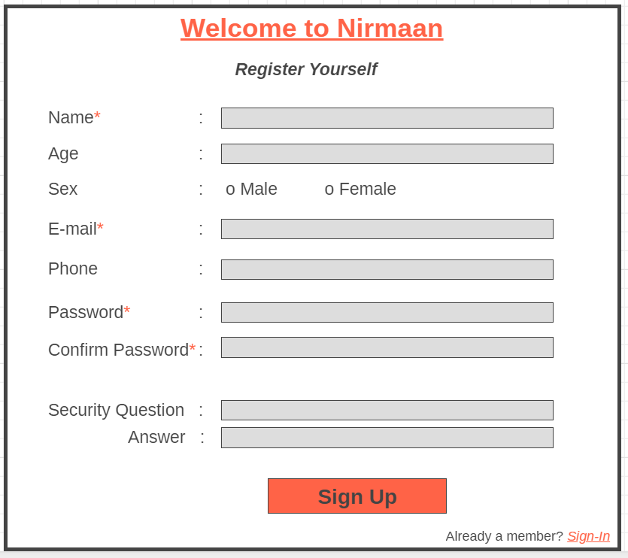

Hotel Booking information page:
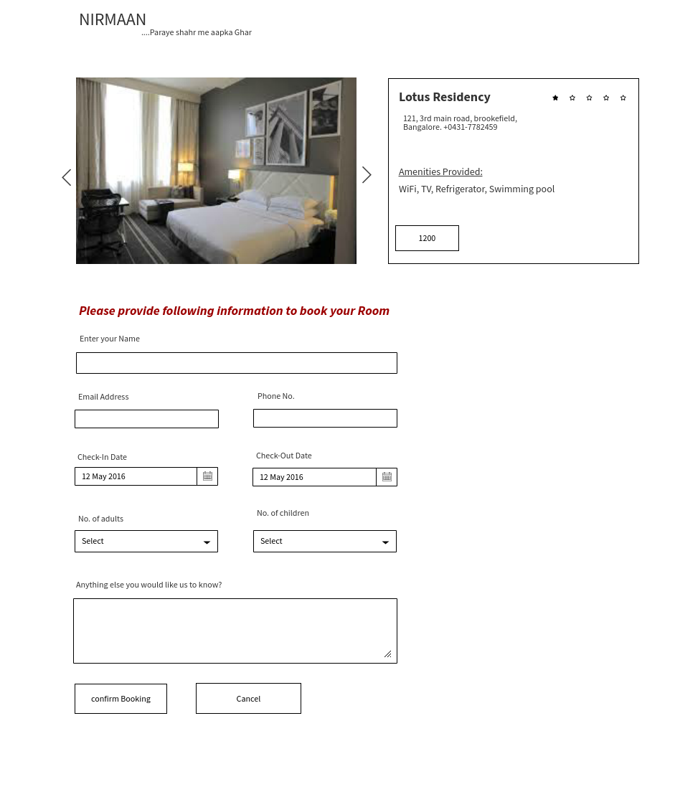

Payment page:
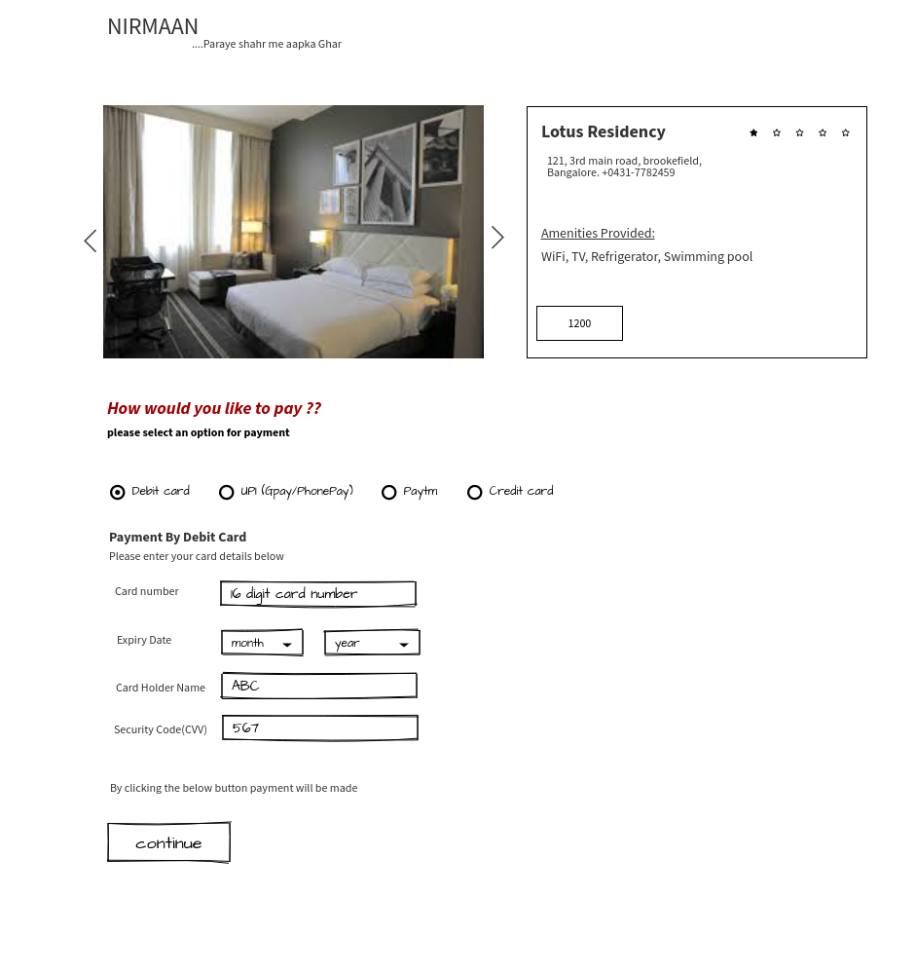
Confirmation page:
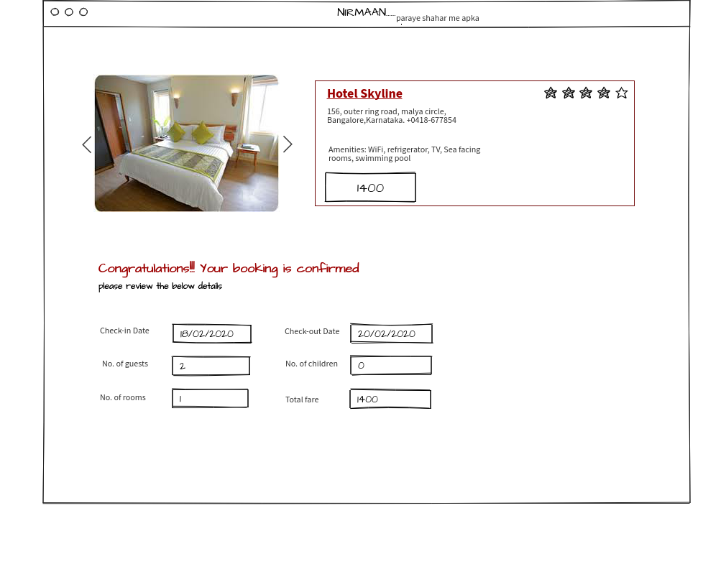
Admin activity page:
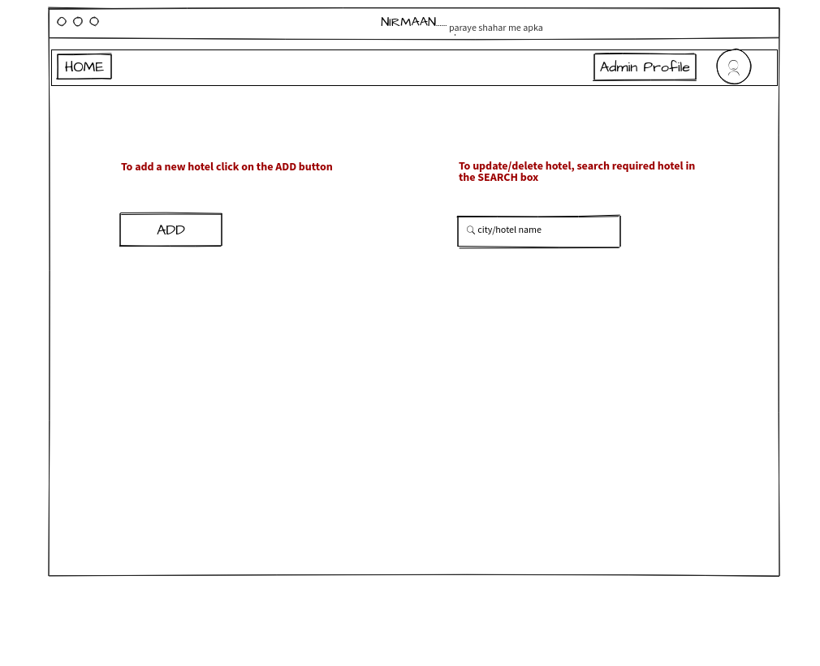
Add hotel page:
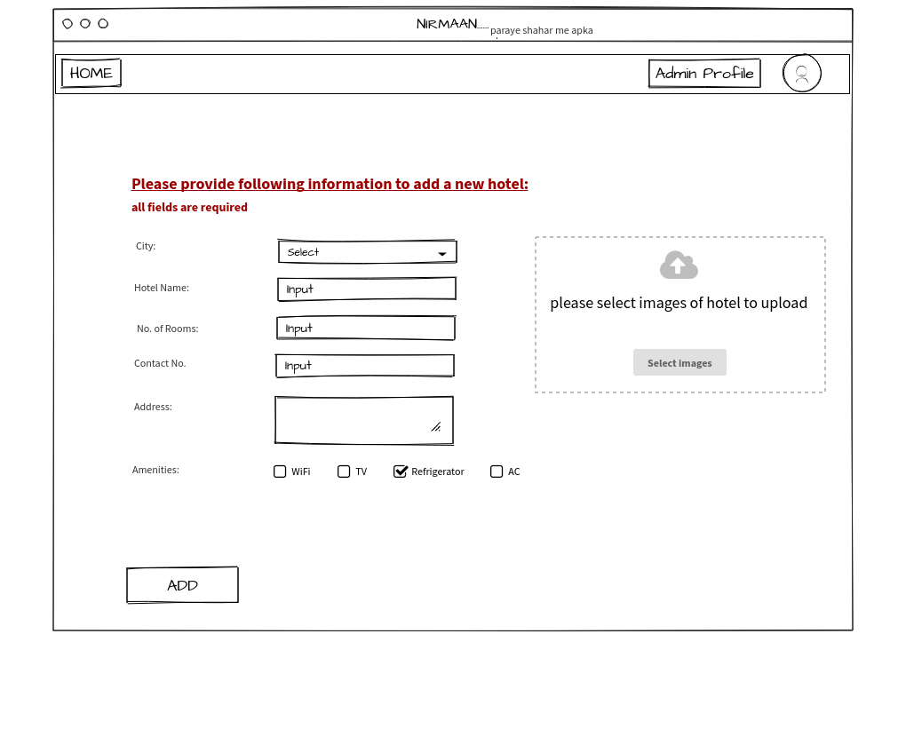
Admin – Search hotel page:
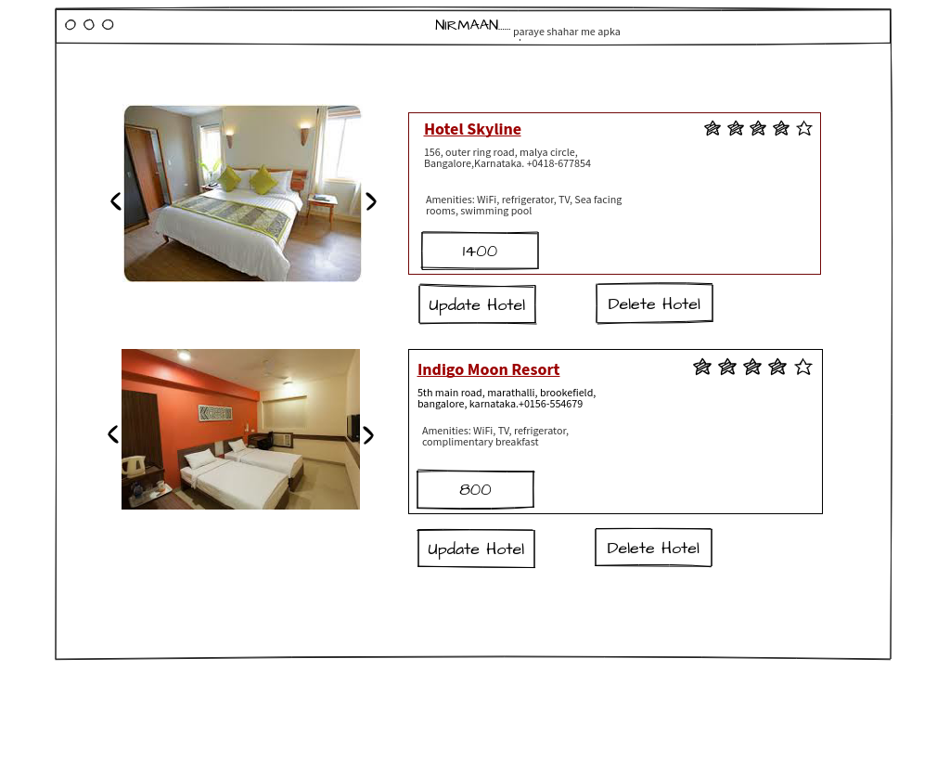
Update hotel page:
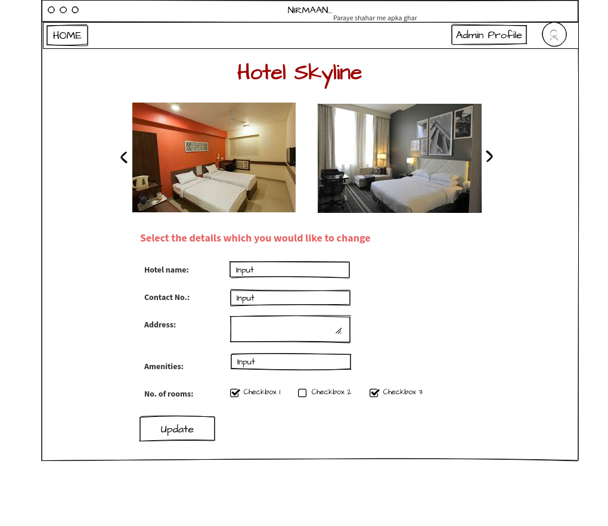

Hotel exploration page:
